**Lab 8**

21k-3278 Sohaib Sarosh Shamsi

**Task 01:** write a program to print prime number between 2 – 100.

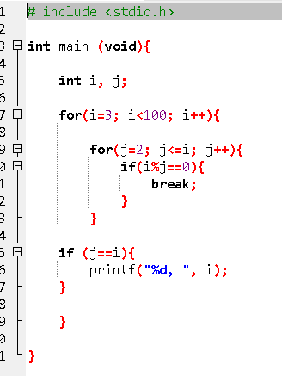

**Task 02:** Write a program that reads the numbers from the user and store these numbers into an array of the same size. Find and display the sum of all positive numbers and calculate the average.

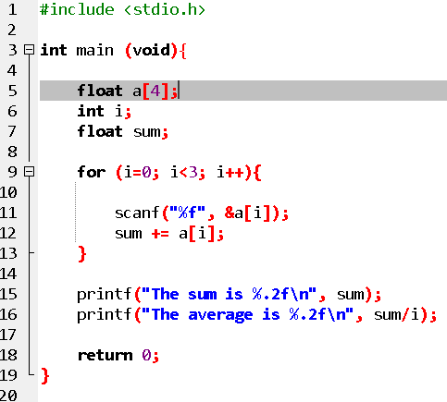

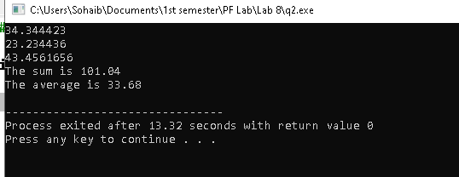

**Task 03:**

write a program by declaring an array for six integer elements. Use for loop to assign the given set {3.14,3.24,3.34,3.44,3.54} numbers to them. Display your stored numbers in descending order as well.

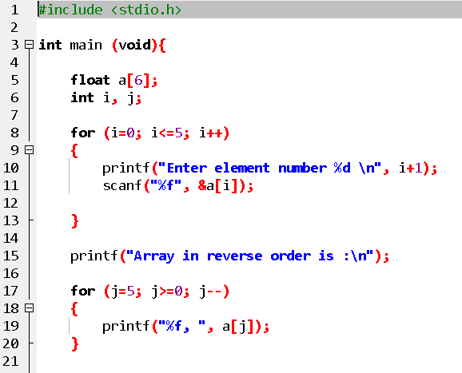

**Task 03:**

Write a program which can store 6 integers. Then check your stored array that it's symmetric or not. As the number of elements are even in a given problem. Make sure that your code is generic and works for odd elements size as well. (Symmetric and Asymmetric differentiated in following figures)

Note: Use Nested loop and Decision statements if required.

**Task 04:**

You are asked write a program which can help him in storing your quiz marks within range [0-10], if the entered marks are greater than 10 then the error message” Wrong Entry should be displayed”. Consider there are 10 students registered in **Section 1E.** He further asks you to find the minimum, maximum, and marks and display them on screen. He is also interested that the marks must be displayed in entered order. Note: Use Loops, 1D-Array and decision statement combination

**Task 05:**

Consider the scenario given in **Task-04** again by considering there are 10 students and you are asked to store their marks in two separate arrays 5 student’s marks in each array. You should also find out common numbers, if there are in both of the arrays and display it. Write a program for the mentioned scenario.

**Task 06:**

Write a program which generates multiplication tables within range (3-10) for odds numbers only.

Note: Use Nested loops

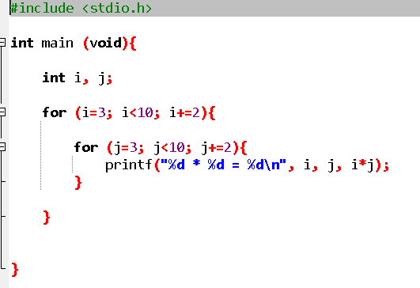

**Task 09:**

**Write the program for the following output given:**

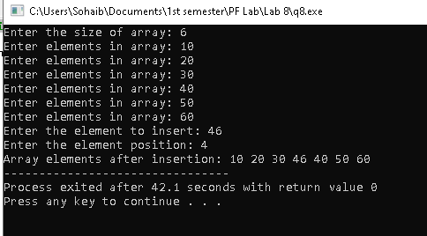

**Task 10:**

Write the program for the following output given:

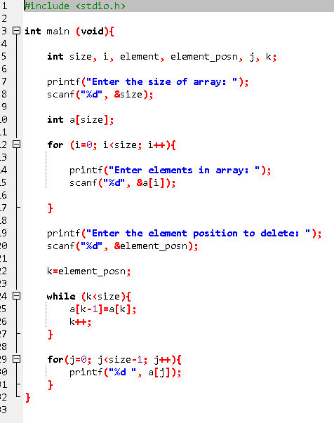

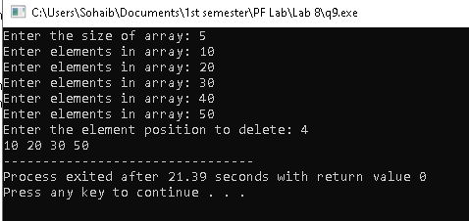

**Task 11:**

Print the following star patterns.

Part1

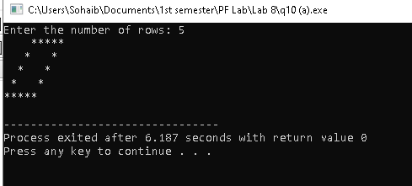

Part 2

